**Activity 12.3 - Mohammed Abdin**

**Submission Instructions:**

Your submission for this assignment should be a Word document that includes the following screenshots, each labeled for the step that the screenshot represents:

1. A screenshot showing that you opened the [Activity 12.3](https://classroom.emeritus.org/courses/10605/files/3007215/download) folder in VS Code.

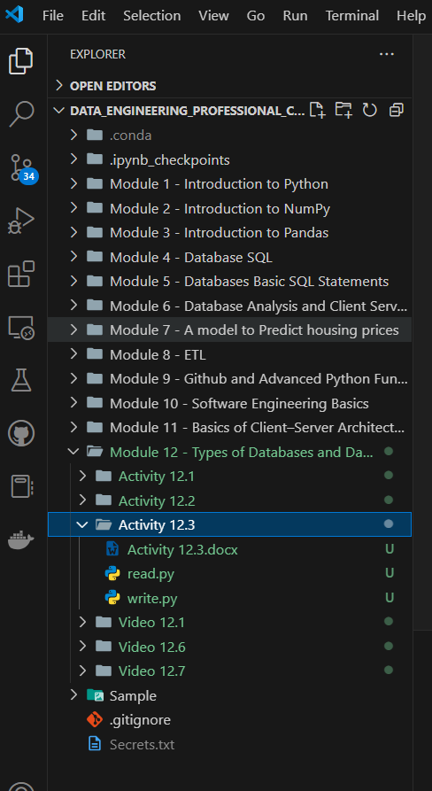

1. Two screenshots showing that you successfully initialized the *container* in your Terminal window and that it is running in Docker.
   1. VS Code terminal:

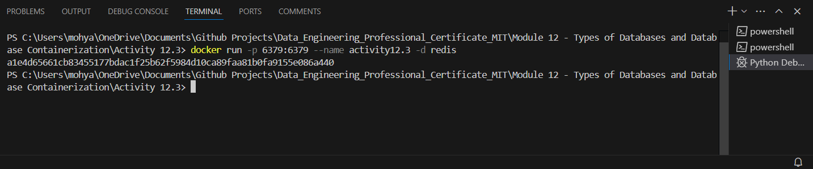

* 1. Docker container:

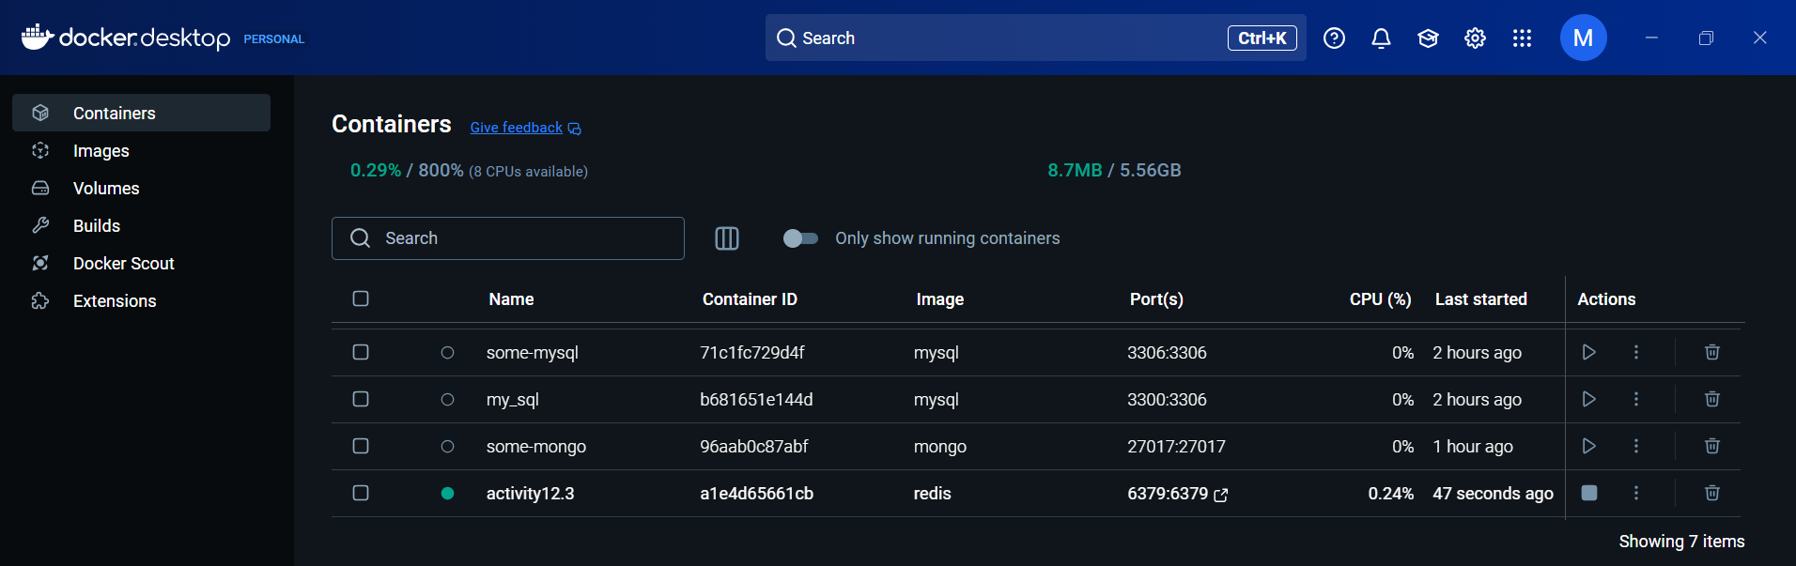

1. A screenshot to show that you successfully defined the *dictionary* in the write.py file.

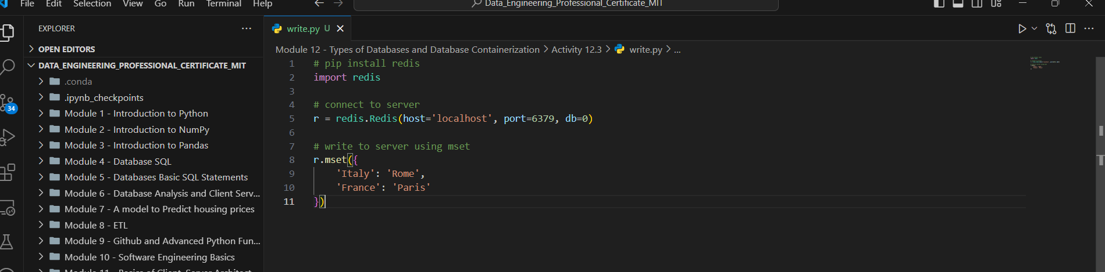

1. A screenshot of your Terminal window to show that the write.py file runs without errors.

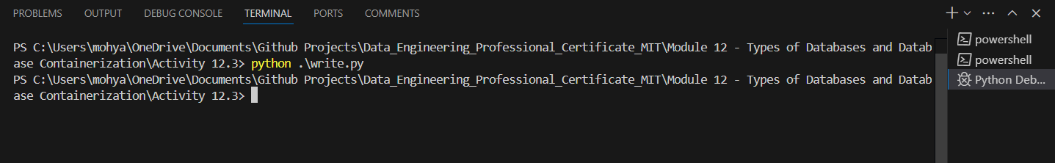

1. A screenshot to show that the read.py file has been modified.

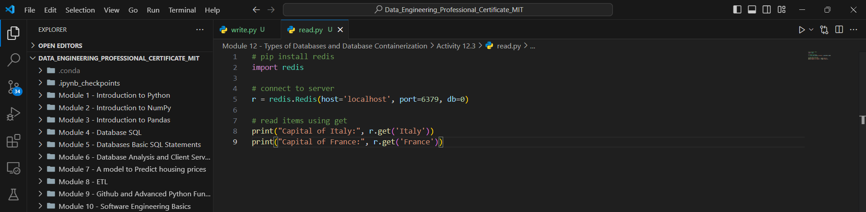

1. A screenshot of your Terminal window to show that the read.py file prints the *dictionary* values correctly.

